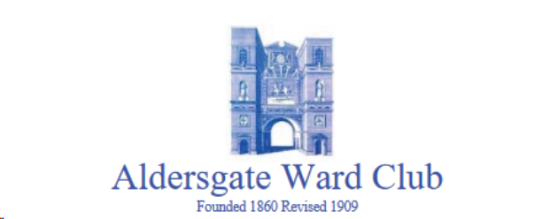
Master: Dr Christopher Eyles
Tel: 01628 487295 - Mob: 07785 984175

Event: Tour of London’s Air Ambulance Helipad and
Royal London Hospital Museum

When: Wednesday 14th August 2019
Meet at: 10:15 by the London’s Air Ambulance Shop adjacent the lobby at the Stepney Way entrance of The Royal London Hospital
Helipad tours: 10:30 Group 1 - 11:30 Group 2
Museum visits: 10:30 Group 2 - 11:30 Group 1
Lunch: 13:00 booked at “White Hart Brew Pub”, 1 Mile End Road, London E1 4TP
Cost: Free (but it is suggested that a donation is made to London’s Air
Ambulance of at least £25.00 per head)

STRICTLY LIMITED TO 20 ATTENDEES ON A “FIRST COME, FIRST SERVED” BASIS.
IN VIEW OF THE LIMITED NUMBER OF PLACES, ONE GUEST ONLY PER MEMBER.

CLOSING DATE FOR BOOKINGS - MONDAY 12th AUGUST 2019

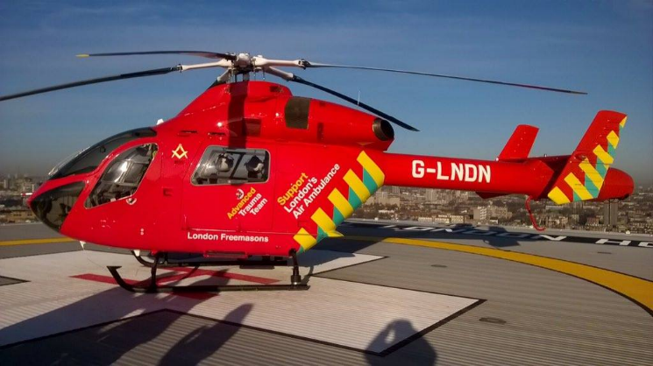
Royal London Hospital One of the charity’s helicopters

London’s Air Ambulance is a charity with its operational base at the top of The Royal London Hospital. During 2018 its advanced trauma doctors and paramedics treated 1,656 patients.

Each of our Groups will be taken from the lobby of the hospital up to the 17th floor for a tour of the helipad and the operational base and will possibly be able to look in on a training scenario for trauma doctors and paramedics. Provided that the helicopter is online and available, we shall be able to have a look around it, enjoy the magnificent views, and take lots of photos. If we are lucky, we may also meet the falconer who visits periodically to frighten away gulls and other birds. While one Group is visiting the helipad, the other Group will have the opportunity to visit the Hospital’s Museum.

Tables for lunch have been reserved at 1.00 pm at the nearby pub and micro-brewery, “White Hart Brew Pub”, which serves a Breakfast Menu until 3 pm as well as Bar Snacks and traditional “Pub Grub”. In addition to the beers brewed on the premises, the usual selection of wines and soft drinks will also be on offer.

Attendees are asked to settle their own lunch bills.

BOOKING FORM

London’s Air Ambulance Helipad and
Royal London Hospital Museum

Please send your reply to Dr C T Eyles at:
Mobile: 07785 984175
or by e-mail to chris@chriseyles.co.uk

Name: .....................................................................

Guest: .....................................................................

NO LATER THAN MONDAY 12th AUGUST 2019

I wish to reserve one/two place/s for the Tour of the London Air Ambulance Helipad and Royal London Hospital Museum

All applications will be acknowledged by e-mail (unless a postal response is requested)

I enclose: (i) my donation to London’s Air Ambulance (Registered Charity No. 801013); and

(ii) my Gift Aid form

OR

I have made an on-line donation

Notes: The Master is happy to collect together your donations to London’s Air Ambulance and your accompanying Gift Aid forms. Alternatively you may prefer to donate on-line at:

https://www.londonsairambulance.org.uk/donate.

We are asked to let “White Hart Brew Pub” know our choice of food before we arrive. Menus will be circulated to attendees during the previous week.

Charity Gift Aid Declaration

Boost your donation by 25p of Gift Aid for every £1 you donate

Gift Aid is reclaimed by the charity from the tax you pay for the current tax year. Your address is needed to identify you as a current UK taxpayer.

In order to Gift Aid your donation you must tick the box below:

I want to Gift Aid my donation of £.......................... and any donations I make in the future or have made in the past 4 years to:

Name of Charity: London’s Air Ambulance

I am a UK taxpayer and understand that if I pay less Income Tax and/or Capital Gains Tax in the current year than the amount of Gift Aid claimed on all my donations it is my responsibility to pay any difference.

My details

Title ............... First name or initial(s) ...............................................................

Surname ..........................................................................................................

Full Home address .............................................................................................

.......................................................................................................................

.......................................................................................................................

Postcode .......................................... Date .......................................................

Please notify the charity if you:

want to cancel this declaration
change your name or home address
no longer pay sufficient tax on your income and/or capital gains

If you pay Income Tax at the higher or additional rate and want to receive the additional tax relief due to you, you must include all your Gift Aid donations on your Self-Assessment tax return or ask HM Revenue and Customs to adjust your tax code.

