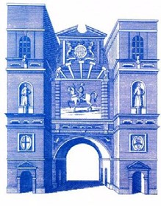
The Master 2019-2020 Ian Kelly
4 February 2020

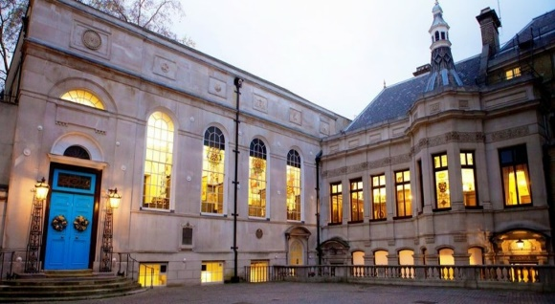
Stationers Hall
In 1666 the Great Fire destroyed Stationers' Hall along with the major part of the City of London. George Tokefield, the Clerk, managed to remove most of the Company's records to his house in Clerkenwell, for which thoughtful act the Company is indebted for the survival of its unique archive.

Dear Member
Tour of Stationers’ Hall preceded by lunch at Cote Restaurant Ludgate Hill MONDAY 16TH MARCH
Members are invited to enjoy a two-course lunch with half a bottle of wine per person at Cote Restaurant Ludgate Hill commencing at 12.30pm followed by a tour of nearby Stationers’ Hall.
Those attending will be asked to pre-order from a menu to be available from 1st March.
The tour of the Hall starts at 14.30pm from the Wren church of St Martin within Ludgate which is now part of the Stationers’ estate.
The visit will take approximately 75 minutes and will be followed by tea or coffee.
Given the age of the Hall there are a few flights of stairs but for any with mobility problems there are ways of dealing with the stairs providing we are advised in advance.
We are limited to 20 places, so early booking is advised.
The inclusive cost is £45 per person
Applications will be taken on a 'first come first served' basis.

ALDERSGATE
The Master 2019-2020 Ian Kelly
4 February 2020

Booking form for lunch at Cote Ludgate at 12.30pm on Monday 16th March 2020 followed by a tour of Stationers’ Hall.
I WISH TO APPLY FOR _______ COVERS @ £45 per person
I have paid by bank transfer to:
NatWest Bank 134 Aldersgate Street, London, EC1A 4JA
Sort Code 60-05-37
Account Number 45430462
Ref: Surname – Stationers
Or
I enclose a cheque for £ made payable to Aldersgate Ward Club.
Please send booking form and cheques to me: IAN KELLY, 41 Fieldway Crescent, Highbury, London N5 1PU (mrkelly1943@gmail.com)

