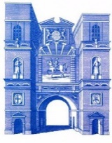
Aldersgate Ward Club
Founded 1860 Revised 1909
Master: Ian Kelly

MONDAY 23RD DECEMBER 18.30 A CHRISTMAS CAROL
ST BARTHOLOMEW THE GREAT, SMITHFIELD

The Master Ian Kelly invites you to join a service of readings from Dickens, together with carols he would have heard and known.

Many of the images we are familiar with at Christmas come from the Victorian era, and especially Charles Dickens’ book, A Christmas Carol.

A special feature of the service is that we are joined by descendants of Dickens, who will contribute to the readings.

At the conclusion of the service mulled wine and mince pies will be available in the cloister.

For those who might wish to go on for supper, Carluccio’s, West Smithfield will be open.

In order to obtain reserved seating it is important those wishing to attend advise the Master by e-mail (mrkelly1943@gmail.com) or telephone 07720 428005 by Friday 13th December latest.

No charge will apply, however a collection will be taken during the service in support of the work of the church

PLEASE ARRIVE BY 18.00

