

Master : Dr Christopher T Eyles
Telephone: 01628 487295 - Mobile: 07785 984175
e-mail: chris@chriseyles.co.uk

Event: Ceremony of the Keys- Tower of London

When: Monday 7th October 2019

Meet at: “Brasserie Blanc”, 14 Trinity Square, Tower Hill, London EC3N 4AA
for a 3 course dinner

Dinner: 6.30 pm until 8.10 pm

Tour begins : 8.30 pm very promptly at the West Gate of the Tower of London

Cost: £70.00 per person

CLOSING DATE FOR BOOKINGS - THURSDAY 3rd OCTOBER 2019

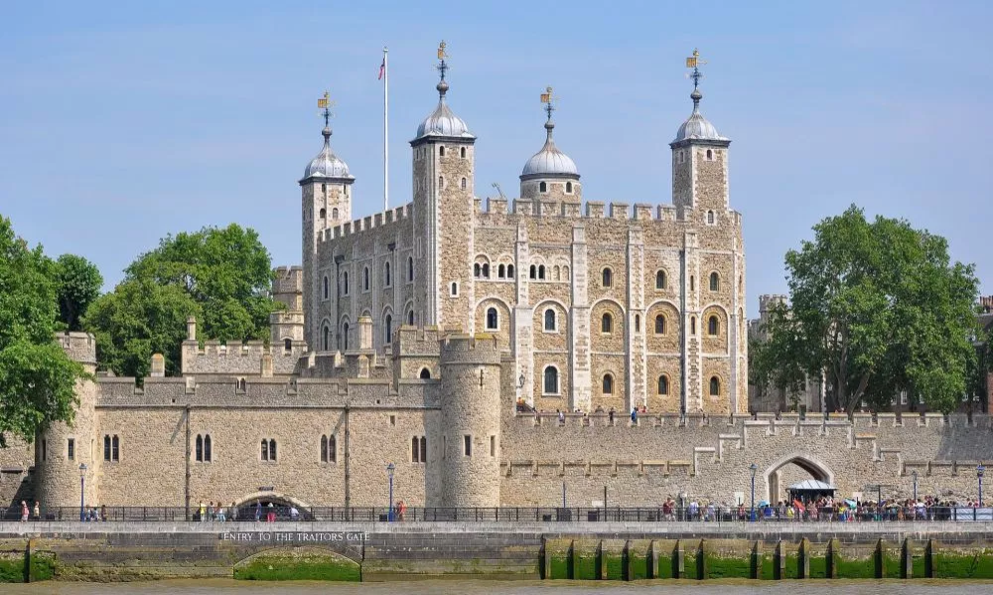

We are privileged to be able to witness the Ceremony of the Keys which is the traditional locking up of the Tower of London each night. It is one of the oldest and most colourful surviving ceremonies of its kind having been enacted every night, without fail, for well over 700 years in much the same form as today. The ceremony has never been cancelled and only delayed once when during the Second World War a bomb knocked a couple of warders off their feet.

After dinner we will walk to the West Gate of the Tower of London where our identities will be checked. We will then be given an hour-long private tour of the grounds of the Tower of London by a Yeoman Warder before being assembled at Traitors Gate to witness the historic ceremony. With the Tower secure for another evening, we will depart at 10.05 pm.

Timetable of events:

1. 6.30 pm - meet at Brasserie Blanc, 14 Trinity Square. Tower Hill,
London EC3N 4AA for a three course dinner.
2. 8.10 pm - leave restaurant.
3. 8.25 pm - assemble at West Gate of the Tower of London (bring identification in case it is needed).
4. 8.30 pm - a private tour lasting one hour led by a Yeoman Warder of the exterior of the buildings within the Tower.
5. 9.30 pm - briefing about the Ceremony of the Keys and the ceremony itself by Traitors Gate.
6. 10.05 pm - departure from the Tower of London.

BOOKING FORM

CEREMONY OF THE KEYS, TOWER OF LONDON
MONDAY 7th OCTOBER 2019

Please send your reply to Dr C T Eyles at:

8 Millbank, Mill Road, Marlow, Bucks SL7 1UA

Tel: 01628 487295 - Mobile: 07785 984175 - e-mail: chris@chriseyles.co.uk

Name: .....................................................................

Guest(s): .....................................................................

NO LATER THAN THURSDAY 3rd OCTOBER 2019

I wish to reserve ____ place/s at £70.00 each for the “Ceremony of the Keys” event (including a 3 course dinner)

I enclose a cheque for a total of £_______ payable to Aldersgate Ward Club

OR

I have made a bank transfer of £______ to Sort Code: 60-05-37 - Account No. 45430462 in the name of Aldersgate Ward Club quoting my surname and “KEYS”

The menu will follow.

